**Highlights from**   
[](http://bclaconnect.ca/2016-conference/files/2014/10/JPEG300_big.jpg)

**Under the Hood: Honest Stories about Disruptive Change in a Public Library**

The session described the organizational change that took place at the North Vancouver District Public Library (NVDPL) over a two-year period.

* 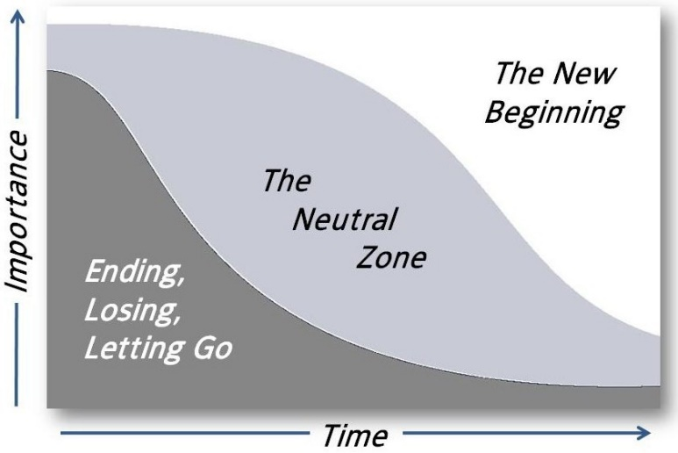Change was occurring due to the economic downturn and a massive change within the organization- 1/2 the management left NVDPL
* New director, Jacqueline van Dyk, rejoined NVDPL in 2013, staff was disengaged, unwelcoming, morale was lacking, and staff felt that the library was too hierarchical.
* There was a lot of change going on, which was disruptive. [Read about William Bridges’ Transition Model](http://www.moravian.org/wp-content/uploads/2013/06/Bridges_Transition_Model.pdf) as it explains the transition process that employees experience during periods of change and how to help staff through the process.
* Jacqueline’s first goal/the library’s shared vision was to focus on the workplace culture: *“we don't need more command and control; we need better means to engage everyone's intelligence …” -Margaret Wheatley* and *“We believe that people perform better when they bring their whole selves to work” Barret Values Centre*
* Another change was to engage Circ staff- more freedom to answer reference questions and provide readers’ advisory; freedom to create book displays; diversifying roles by training and experience. As a result, Circ staff felt more valued and felt *seen*, as opposed to feeling dismissed when all decisions were made exclusively by librarians.
* One project that helped build morale was a website redesign that all staff collaborated on. They worked as a team, instead of outsourcing the project, and played on staff strengths. Staff could choose any part of the project to be involved in, to whatever extent they felt comfortable.
* Tips from the Manager: be intentional about *how* you want to work together, set values and stick with them. It is most helpful to have these values established when dealing with heated discussions. Be social, time together outside of work and getting to know/like each other personally makes it easier to reach out to one another. Be transparent with the learning process, including what works and what doesn’t, living and leading by example.

**What's Really Going on When it Looks Like We Are Just Singing?**

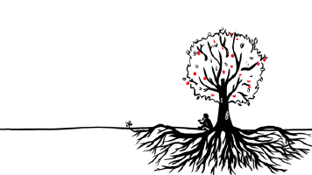In this session three children's librarians explained what's really going on in terms of children's brain development, relationship building, empowering parents, building lifelong learners etc. when it looks like they're *just* singing and playing with puppets during storytime. I learned *a lot* from this session.

* Imagine the whole process of children's programming like a tree, with roots (values), trunk/core(evidence based practice) and fruit (benefits/outcome).
* *Roots/values*: When planning a program consider: Access: are there any barriers to your services? Fines on cards? Many parents are worried that their children wont behave properly in the library and avoid the library because of this. Privacy: We're in a culture of mass surveillance- how can we empower parents to protect kids' privacy? Democracy: How can we help children feel engaged/feel like citizens in the community? Lifelong Learning: Library space can engage in lifelong learning, as opposed to simply supporting formal education, by creating fun/pleasurable, child-driven learning experiences. Service: How can we provide excellent customer service? Ex. automatic renewals and text messaging on day of program. Social Responsibility: Focus on understanding your community; learn your community's [EDI Results](http://earlylearning.ubc.ca/maps/edi/nh/sd37/). Diversity: Create a diverse collection, inclusive spaces, ex. [Safe Harbour](http://www.amssa.org/programs/diversity/safe-harbour-respect-for-all/about/). Intellectual Freedom: Teach children critical thinking skills.
* *Trunk/core (Evidence Based Practice):* Many studies have been conducted showing that the first 3 years of life are most important for creating neural pathways in the brain, so babies should be read to starting from day 1; parents are the most important teachers in child's life. More data: [VIEWS2](http://views2.ischool.uw.edu/welcome-librarians-educators/).
* *Fruit (Benefits/Outcome):* Two great examples of programming were 1) Moving the regular storytime to a nearby park with neighboring community playground and garden. This addressed physical literacy- children played at the park before the storytime. Parents met earlier before the program and connected. It was also more comfortable for those parents who felt uncomfortable at the library (afraid children would act out etc.) Collaborated with the community garden to teach the children about gardening. Children gardened after the storytime. 2) SRC Windup Party created *for* children and *by* children, using their ideas (child-driven learning.) Using community information, librarians also felt that it was more valuable to spend money on providing food for the party than to book a performer (food security is a big issue in their community).
* Trends: anything digital; outdoor deficit is a big issue, so focus on emphasizing outdoor play (themes in storytime, storytimes in the park etc.); neurodiversity- services to a broader audience, popular trend- [Sensory Storytimes](http://www.spl.org/audiences/children/chi-for-parents-and-caregivers/sensory-story-times) (receive training through local autism society.)
* Bottom line with programming- focus on the why you are doing the program + the evidence that backs it up + your community's needs, as opposed to just creating a "cool, new program."

**Why the Public Library? Using Service Models to Articulate What You Do and Why You Do it**

Members of the West Vancouver Memorial Library (WVML) spoke about using a service model to help the library stay relevant and viable in times of financial and educational change.

* Service models are working documents that capture the how and why of service delivery.
* They address a specific service population (ex. The presenters recently completed a service model for digital life skills and for early years/kids/teens.)
* Service models articulate all elements of service and aim to document the full cost of a service.
* Are useful because they provide a clear measure of evidence-based outcome. For example, to justify the cost or the importance of a program to board members, you could show them the service model and how it serves the population; how it met the intended outcome, and didn’t go over budget etc.
* Take approximately 100hrs to complete.
* If anyone wants a copy of WVML’s Service Model Template, let me know!

**Making Connection: Knowing Our Immigrant Communities**

This session reviewed two research studies that were conducted by the Burnaby Public Library (BPL), UVic and UBC.

* This first study conducted by BPL was on information seeking behavior of newly arrived immigrants. Two groups that were found to be struggling were older immigrants and those with average to very poor English skills. There was also a high percentage of immigrants who were experiencing frustration finding information. You can find further details about the study [here](https://librarytoolshed.ca/content/information-seeking-behaviours-new-immigrants).
* The next study was on the library perceptions, reading habits, and library usage of South Asian users. Some the services requested were having programs in their language; having staff available who could speak their language, and having South Asian newspapers readily available (apparently their newspapers are extremely important to them and are often favored over books or magazines.)
* A good way to get new immigrants involved in the community and gain work experience is with the [Library Champions program](http://newtobc.ca/newcomer-resources/champions-project/).

**Feats and Failures: Creating Memorable Summer Reading Clubs**

The speakers of this session reviewed successes and failures of past Summer Reading Club (SRC) programs. The following are a selection of the most relevant successes and failures:

**Successes**:

* Weekly Programs: Since many children go on vacation during the summer and cannot complete the entire SRC program, it's a good idea to have weekly/drop-in programs. Ex. Scavenger hunts are very popular.
* Flight Storytime: A very successful program was a flight storytime. The storytime took place in a park near the library. The librarian read flight related books and then followed the program with a paper airplane making craft. The kids then tested their paper airplanes, competing with each other etc. The storytime was just for Dads and children, and had a huge turnout. (There was an immigrant Dad and son who attended the program and really enjoyed it; they had never made a paper airplane before this program!)
* Cardboard Challenge: This idea was mentioned in more than one session I attended. It involves collecting used cardboard boxes from various places (ex. Furniture stores carry huge cardboard 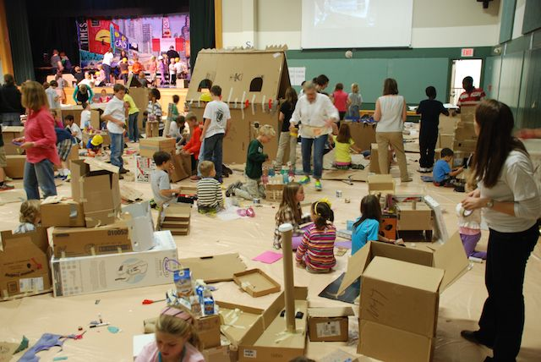boxes!) and creating a program for children where they can create anything out of cardboard boxes. Other supplies are included to add to their creations: magnets, pompoms, colouring supplies etc. Apparently this is a very popular program!

**Failures**:

* Class Visits: Registering students for SRC during class visits was found to be a failure. Too many students lost their SRC booklets at school, and/or forgot program instructions, thus were unable to explain the program to their parents and complete or even start the program. The statistics for this method over a wide range of libraries was approximately 10,000 students registered at class visits and only 1500 returned to the library to complete the program. (The solution was to provide students with *information* about SRC at class visits, but only register students at the library.)
* Parental Expectations: One failure was in regards to SRC programming. SRC programming descriptions weren't clear in stating that parents were to be present at programs. Many parents had intended to drop off their (young) child at a program and were upset when they were told that they must stay with the child. Some parents refused to bring their children back to subsequent programs. (The solution to this problem was clear parental expectations. For example, programs for ages 3-5, "Parent/caregiver must attend program with child;" programs for ages 6-9, " Parent/caregiver may drop off child but must remain in library," and programs for ages 10 and over, " Parent/caregiver may drop off child."

**I Want to Be Open!**

This session was about the Open Movement- open software, open textbooks, open data etc. Open is currently a hot topic in universities! (Open Access is online, digital, free of charge and free from most copyright and licensing restrictions.) I'm familiar with the Open Movement and have used open source software (OpenOffice, Linux, GIMP), as well as open education (Alison.com, MOOC) and data. but this session was a bit over my head, as it was geared towards academic librarians and focused heavily on open textbooks. However, I did learn more about the Open Movement and resources that could be helpful if I'm ever helping university students, or anyone interested in open education, at the Info Desk.

* To get started, plan an "Open" event or display. November is Open Access Week and March is Open Education Week.
* Find faculty/staff (IT staff?) and start asking questions about including Open software in your organization. (For example, why don't we have OpenOffice on our word processors. Or Linux instead of Windows? They're free!)
* Become familiar with the benefits of open access: reduces costs, provides more relevant/engaging material, assures academic freedom by allowing modification/adding content etc.)
* To learn more follow *@bcoer @oerlib @openeducationweek @openeducation @liboer* on Twitter
* Resources: [TRU's Open Access LibGuide](http://libguides.tru.ca/openaccess) and [Kwantlan's Open Data](http://libguides.kpu.ca/c.php?g=183983&p=1212607).

**Health and Safety for Library Workers**

This session presented the results of a study given to more than 500 library workers from academic, k-12, and public libraries across the province.

* The most frequent unsafe situation library workers deal with was intoxicated patrons, followed by verbal threats and incidents requiring a patron being banned.
* A large percentage of workers felt uncomfortable refusing unsafe work and were unaware that they had that right to refuse unsafe work.
* Recommendations included training more than the conventional RSI training. Staff would like to learn how to deal with unsafe situations and mental health issues in the library.
* If anyone would like to read a copy of the Library Health & Safety Report Survey and Interview Results, I'll leave it on my shelf in the workroom- feel free to read it!

**Partnerships for Change: Re-invigorating a Downtown Library**

This was a very interesting discussion on the changes that are happening (and the future plans) for the Kelowna branch of the Okanagan Regional Library (ORL), including its collaboration with the University of British Columbia Okanagan (UBCO). This session was particularly interesting because I grew up in Kelowna, graduated from UBCO, and had my first library job with ORL!

* The Kelowna branch was built in 1994 and since then the community's needs have drastically changed- more students because of UBCO, increase in home based businesses, increased technology needs.
* Started partnerships with UBCO, the City of Kelowna and the neighboring, Centre of Innovation.
* UBCO Collaboration- wanted to create a community presence for the University in downtown Kelowna, since the University is ~20min from the downtown. They created an innovative space for UBCO students within the library, complete with laptops and study space. It is staffed by a UBCO librarian 20hrs./week to support researchers.
* The last portion of the session discussed ORL's future plan for the library's re-design, including a makerspace on the first floor with 3D printers; a business hub where individuals with home based businesses can meet/work; a recording studio; an additional Great Room that can be used for storytimes, yoga classes etc.; improved entry experience; utilizing space under the stairs for a fun, "nook" seating area; increasing natural light, and improving customer service points.
* You can see a photo of the future makerspace in the Urban Arts brochure, also on my shelf in the workroom.